Lab 4 plus
*Lab 4 plus is a combination of Lab 4 and an extra activity on ARP.

Packet Tracer Simulation – Exploration of ARP and Switch Table Communications

Objectives
- To explore ARP and switching operations.
Introduction
The topology is given to you. All IP addresses have been assigned to all devices. Please follow each step in sequence.
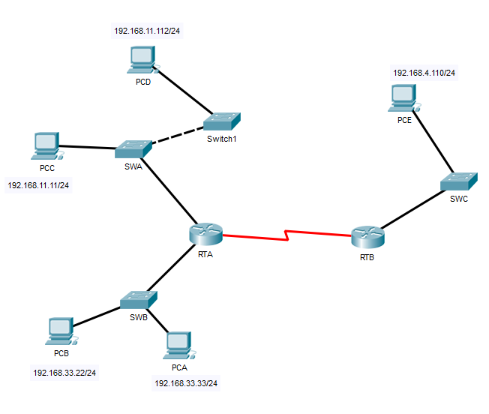
Figure 1

Part 1: Review the topology

Step 1: Perform the following tasks.
RTA>enable

RTA#show arp
- At Router RTA, enter the CLI. At the command prompt type the following commands. Snap the results after the last command and paste it here.

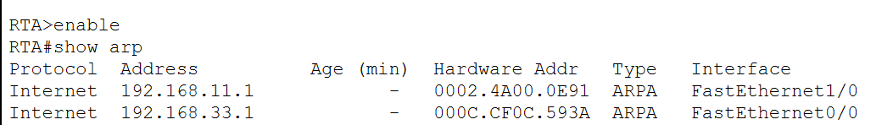

- At Router RTB, enter the CLI. At the command prompt type the commands as in Figure 2. Snap the results after the last command and paste it here.

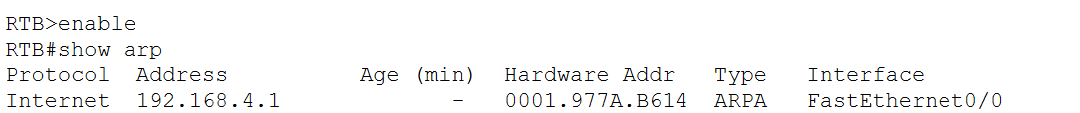
- At Switches SWA, SWAB and SWC, enter the CLI. At the command prompt type the following commands. Snap the results after the last command and paste it here.
SWA>enable

SWA#show arp

SWA#show mac-address-table

SWA:
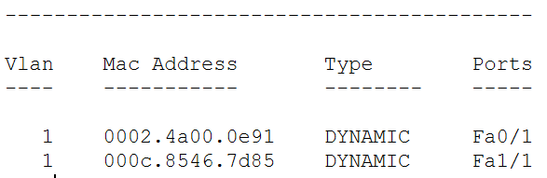

SWB:

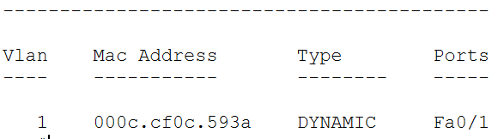

SWC:

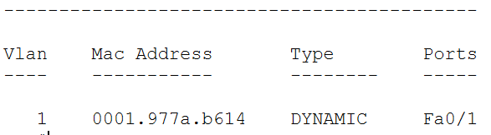

- At PCA, click on the PC icon, and then choose Desktop-Command Prompt. At the command prompt type arp –a and click enter. Snap the results after the last command and paste it here. Do this to all PCs in the topology.

PCA:

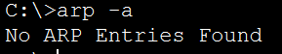

PCB:



PCC:

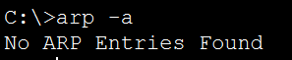

PCD:



PCE:


- What are your thoughts on the results?

These PCs have not yet resolved any IP addresses to MAC addresses. The PCs have not sent or received traffic requiring ARP resolution and are not properly connected to the network or are misconfigured. ARP tables are cleared or inactive because no network activity has occurred.

Part 2: Generate Network Traffic

Step 1: Generate traffic between PCA and PCB.
In the command prompt Perform the following tasks task to reduce the amount of network traffic viewed in the simulation.
- Click PCA and click the Desktop tab > Command Prompt.
- Enter the ping 192.168.33.22 command. This may take a few seconds.
- In the Command prompt of PCA, type arp –a. Paste the result of this command here.
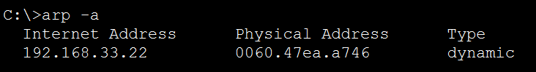
- In the Command prompt of PCB, type arp –a. Paste the result of this command here
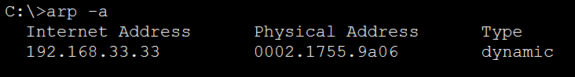
- In the Command prompt of PCC, PCD abd PCE, type arp –a. Paste the result of this command here.
PCC:
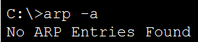
PCD:

PCE:


Step 2: Generate traffic between PCC to all other PC except PCA.
- Click PCC and click the Desktop tab > Command Prompt.
- Enter the ping 192.168.33.22 command (ping to PCB). Then type arp –a. Paste the result after these commands here.
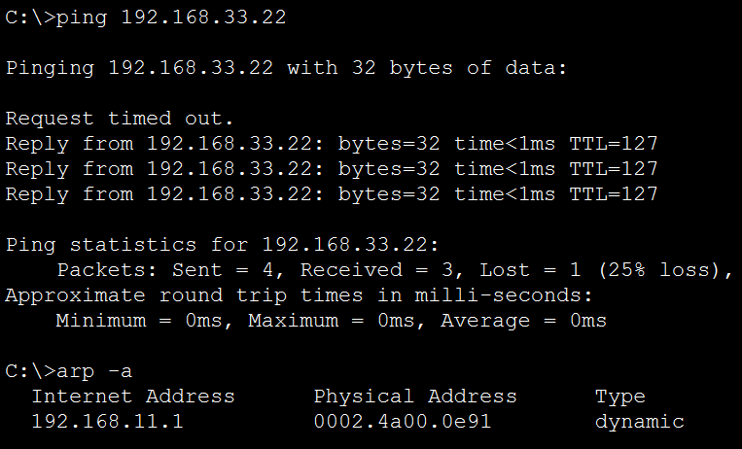
- Enter the ping 192.168.11.112 command (ping to PCD). Then type arp –a. Paste the result after these commands here.
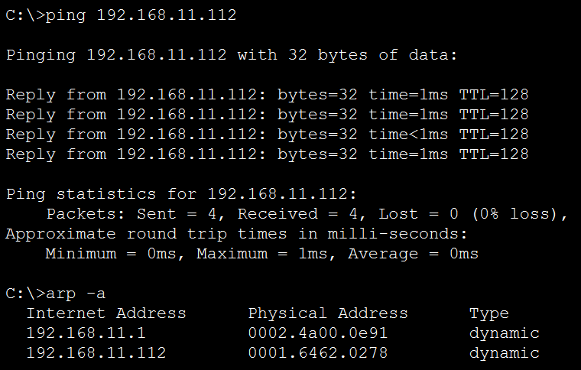
- Enter the ping 192.168.4.110 command (ping to PCE). Then type arp –a. Paste the result after these commands here.
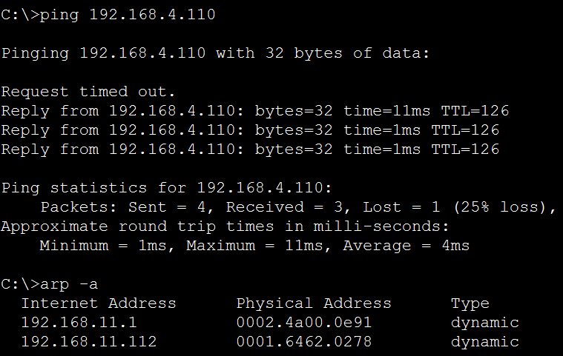
- Discuss the results you got from all the commands on PCC.
The results show that PCC can communicate with devices in other subnets, although there are minor delays and inconsistencies with ARP table updates. The initial packet loss for PCB and PCE indicates the time required for ARP resolution.

- At Router RTA, enter the CLI. At the command prompt type the following commands. Snap the results after the last command and paste it here.
RTA>enable

RTA#show arp

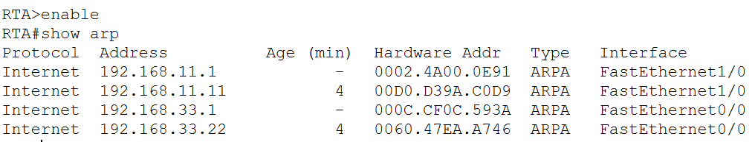
- At Router RTA, enter the CLI. At the command prompt type the following commands. Snap the results after the last command and paste it here.
RTB>enable

RTB#show arp
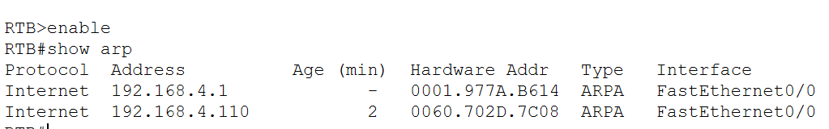

Step 3: Switch MAC address table.
- At Switch SWA, enter the CLI. At the command prompt type the following commands. Snap the results after the last command and paste it here.
SWA>enable

SWA#show arp

SWA#show mac-address-table

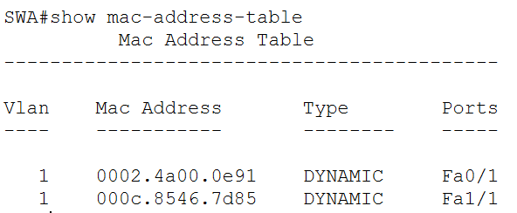
- At Switch SWB, enter the CLI. At the command prompt type the following commands. Snap the results after the last command and paste it here.
SWB>enable

SWB#show arp

SWB#show mac-address-table

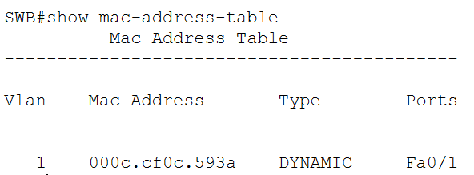

- At Switches SWC and Switch1, enter the CLI. At the command prompt type the following commands. Snap the results after the last command and paste it here.
SWC>enable

SWC#show arp

SWC#show mac-address-table

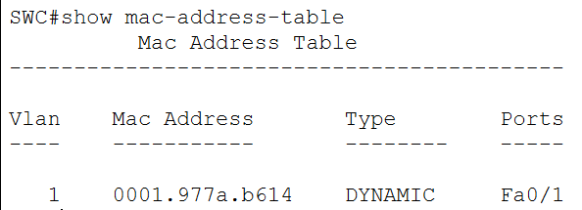
- Do switches use arp table? (Y/N)
No, switches do not use ARP tables.

- Explain your answer in (d) *Hint: the answer may surprise you. Google for the explanation. It is not part of NetComm syllabi, it is just for knowledge..
ARP tables map IP addresses to MAC addresses. They are primarily used by devices that operate at Layer 3(Network Layer), such as routers and end devices like PCs, to enable communication between devices in the same or different subnets.
Switches use the MAC address table to forward frames to the appropriate port. They learn MAC addresses dynamically by examining the source MAC address of incoming frames and associating it with the port on which the frame was received. Switches operate at Layer 2(Data Link Layer).

- What information does the command show mac-address-table gives?
The command provides details about the MAC addresses learned by the switch and their corresponding ports. Specifically, the VLAN to which the MAC address belongs. The unique hardware address of a device connected to the switch.(MAC address), the type of MAC address entry and the specific switch ports associated with the MAC address.

Part 3: Attach wireless lab results.
In this part, you will use Lab 4 .pka file.
Step1: Change the filename of Lab 4.
- Change the Lab 4 filename to include your name. *Example: Lab4AliAhmad.pkt
- Go through the instructions. As you complete the tasks, you will see the bottom right hand corner of the pkt file increase in completion percentage, until you get 100/100.

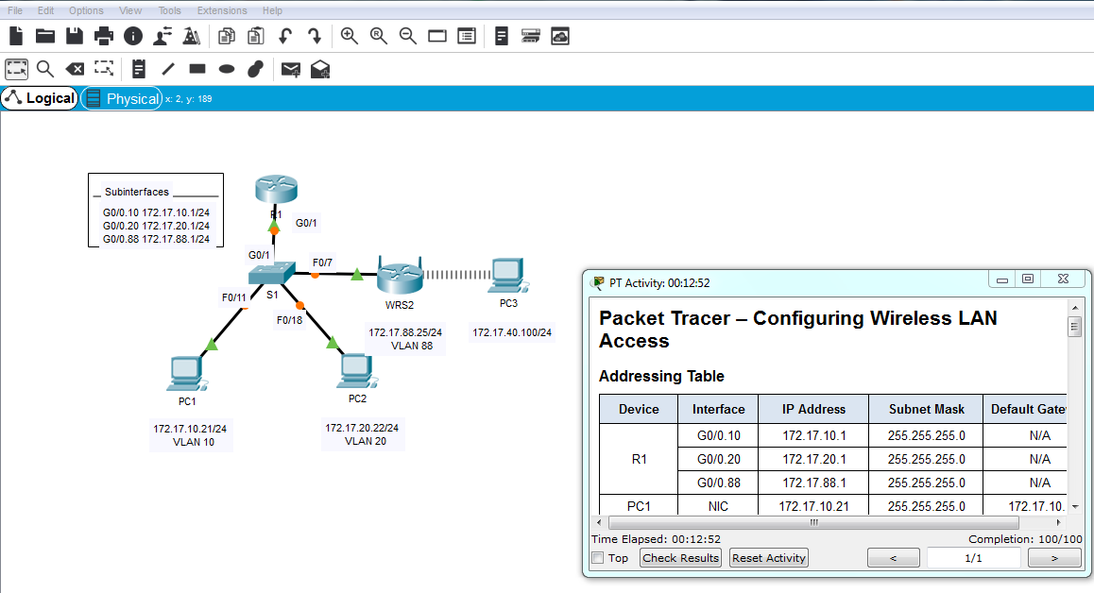
- Once you have completed fully, capture the screen (which includes the filename, the topology and the activity wizard showing completion) and paste it here.
